  What is the Order of the Eastern Star?  The Order of the Eastern Star is the largest fraternal organization in the world to which both men and women may belong. Our teachings are based on the Bible, and while we do require a belief in the existence of a Supreme Being, we are neither a religion nor a secret or political society. Our symbol is the star of Bethlehem with the five pointed star as our accepted emblem. Business meetings are conducted with an open Bible on the altar and the flag of our country displayed. __________  Chapter meets the __________ of each month September thru June at 7:30 pm.  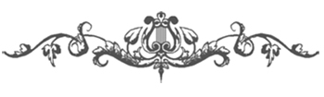  The Order of the Eastern Star is a social order and we at ____________ Chapter have an active social club that meets once a month for lunch, separate from our regular monthly meetings.  The Order of the Eastern Star provides us with an avenue of compassion and concern, not just for our fellow sisters and brothers in the Order, but for ourselves, our country and our faith. Many of our members are active in other community and fraternal organizations, as well as volunteering with local charities and within their places of worship. |  |   Who may join?  To join Eastern Star you must:  Be of good moral character  Believe in a supreme being  Be at least 18 years of age  Believe in the laws of the United States  Be willing to assume the obligation of the Order and participate in the ceremony of initiation  Not be convicted of a felony under the laws of any state in the United States  Additionally, you must meet one of the following eligibility requirements:  - All male members must be a Master Mason in good standing. Female members must be related to a Master Mason in good standing in one of the following ways: birth, marriage, or adoption, or if deceased were in good standing at the time of death, or be a member (either active for three years or majority) of the International Order of Rainbow for Girls or Job’s Daughters International or be sponsored by a Sister and Brother of the Order of the Eastern Star with a letter of recommendation signed by both.  Those desiring membership must petition to do so. To obtain a petition for membership, contact a Chapter near you or contact the Grand Chapter of Washington Order of the Eastern Star at grandsecwaoes@comcast.net |  |   XXXXXXXXX  Chapter #XXX  Order of the  Eastern Star  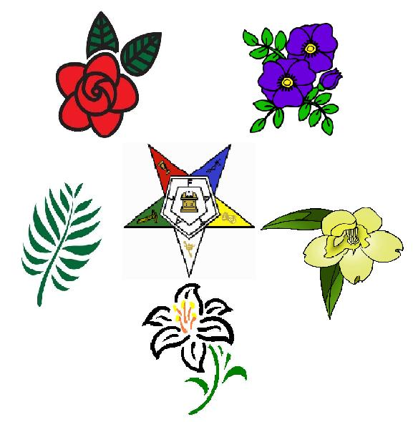  A fraternal organization dedicated to charity, truth and loving kindness  Meeting at  XXXXXXXXX Masonic Lodge  XXXXXXXXXXXXXXXXXXXXX  XXXXXXX, WA  On the XXXXXXXXXXX of Each  Month September Thru June  at 7:30 pm

The stated purposes of the organization are charitable, educational and fraternal.  Our members raise thousands of dollars annually through fundraising activities to support both Eastern Star and local community charities. The Grand Chapter of Washington is committed to helping young people seeking to further their education. We award hundreds of dollars in scholarships each year to deserving young men and women.  In addition, a disaster / benevolent fund is maintained by the Grand Chapter of Washington to assist members who experience loss of personal property as a result of a disaster such as flooding, tornado, fire, etc.  Local chapters are encouraged to promote community awareness through volunteer services and financial assistance to the needy. Here at ________________ Chapter we work to support _________________. We also have members who __________  ____________________________  and in other local events when invited to do so. |  |   What is expected of our members?  Attendance at meetings is not mandatory. After your initiation into our Order during a regular meeting, you may attend as your time permits. There is no “required” obligation of time.  Unless you become an Officer, there is no mandatory memory work except the means of making yourself known should you wish to visit a different Chapter.  We do ask that you keep your dues current, that you inform us of any change of your address and that you join us at our fun, social, and fund-raising events as your time and schedule permits.    What we can  offer you  The members of _________ Chapter are a very diverse and fun-loving group who enjoy getting together for fellowship and mutual support. We pride ourselves on always being there for our Sisters and Brothers in times of distress and need, and to share in each others joys and sorrows. Our members have a wide range of interests, and often will get together to share these interests with each other, whether by teaching one another a new skill, or by sharing their gifts and talents to help raise funds or entertain. By joining our Chapter, you will have the opportunity to participate with us in caring and supporting one another. |  |   Why should I join?  The Order of Eastern Star allows us the opportunity to enjoy fellowship, build friendships and have fun. Our fraternal bond allows us to make a difference in our communities through social activities and charitable causes.  Should a Master Mason join the Order of Eastern Star?  The answer is “YES”.  The female members of the Order are relatives of Masons. By joining the Order of the Eastern Star, a Mason and his wife can share in the benefits of being members of a worthwhile organization that is dedicated to charity, truth and loving kindness. Joining the Order of the Eastern Star does not in any way diminish or alter the Mason’s Masonic effectiveness. To the contrary, our Brothers have remained dedicated to their lodges and the precepts of Masonry. Membership in the Order promotes the concept of the Fraternal Family. It provides a wholesome atmosphere where families can fellowship and work together for the good of others.
   | Our Purpose
  